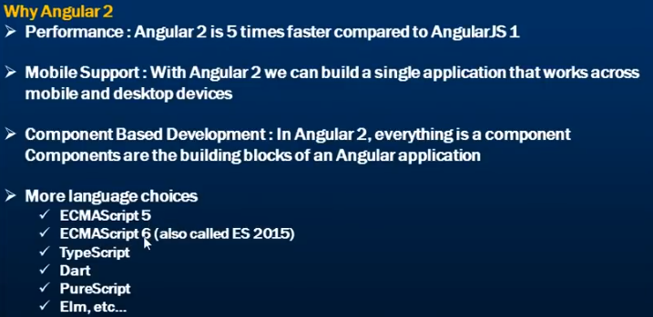  
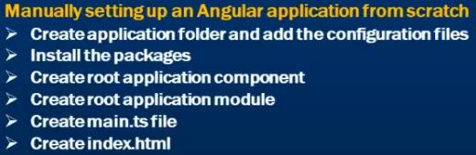

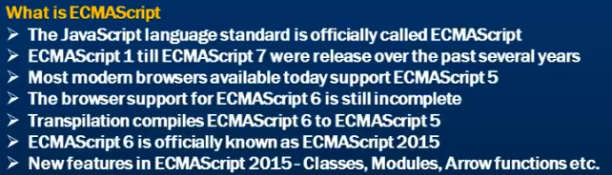

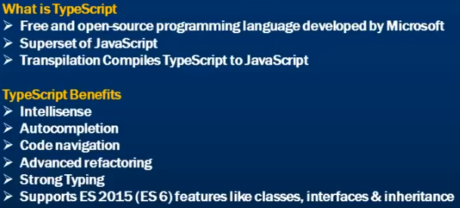

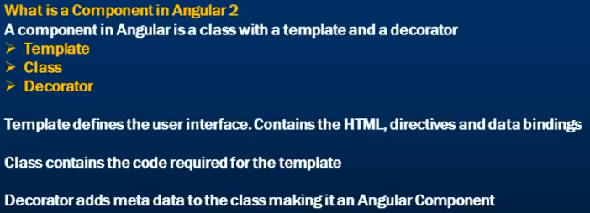

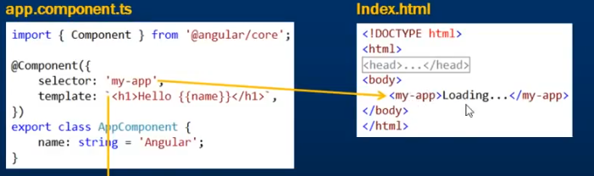

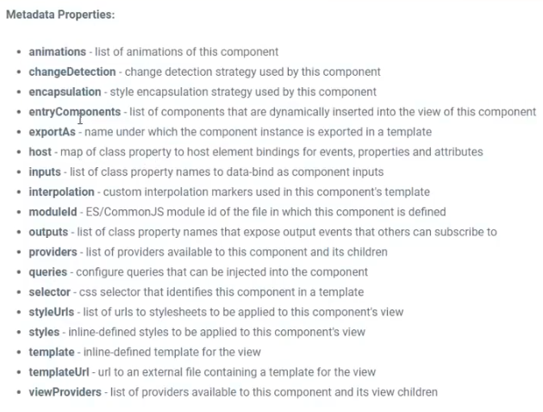

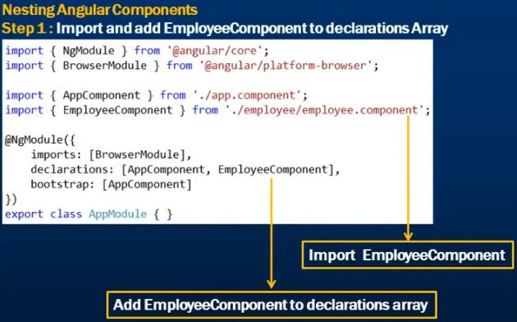

AppModule- AppModule is the root module which bootstraps and launches angular application.

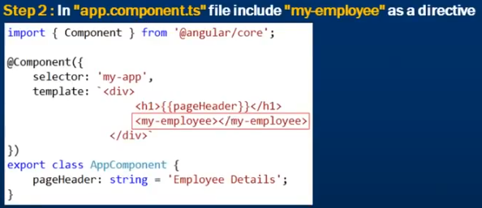

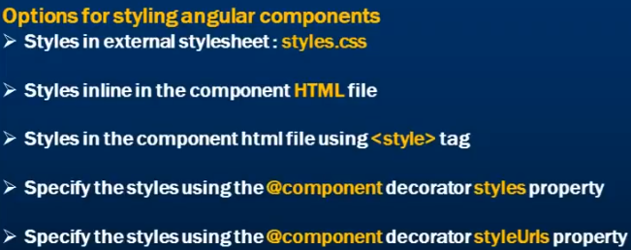

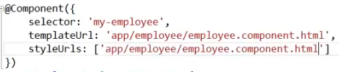

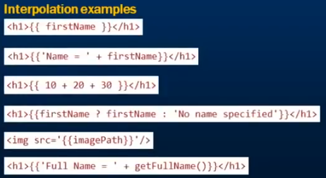

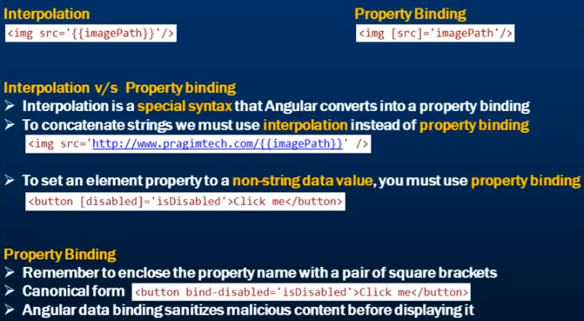

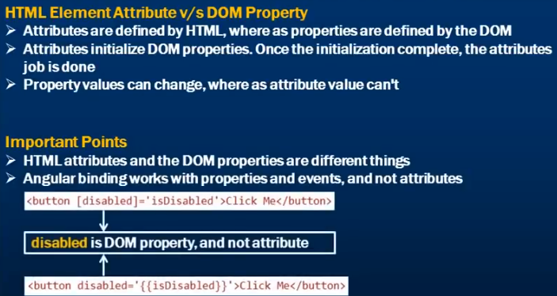

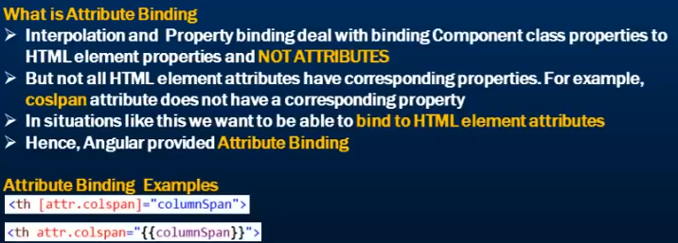 Class Binding

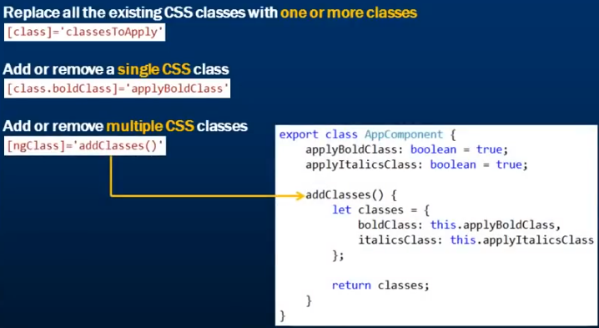

Style Binding: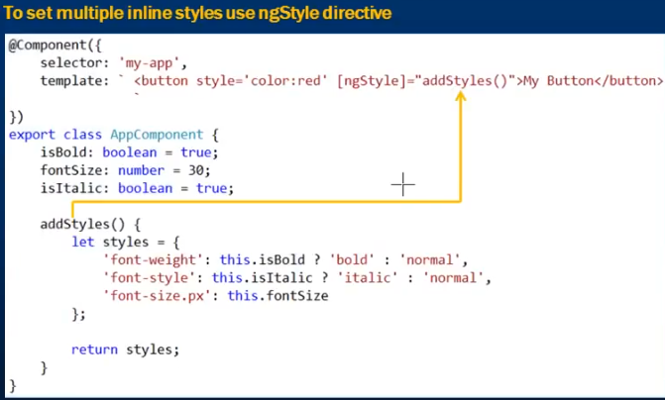

Event Binding: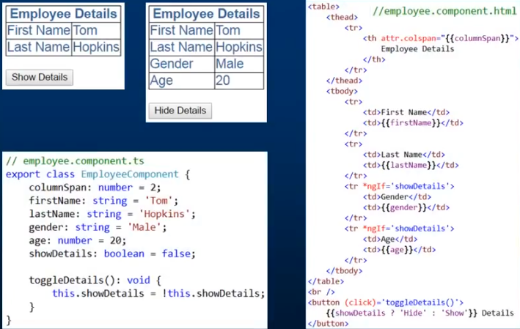

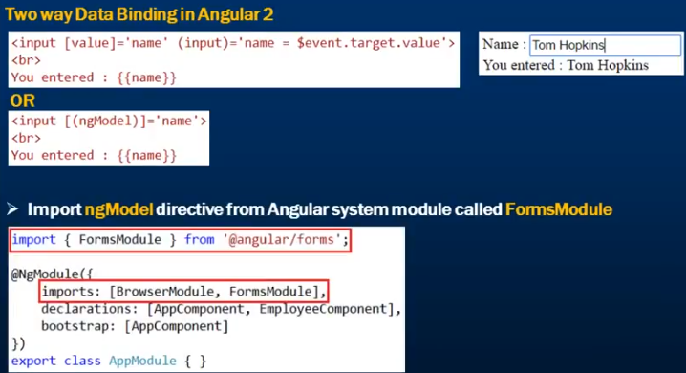

*ngfor:  
*Structural directive: modify the DOM (add or remove)

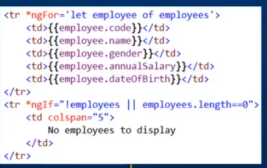

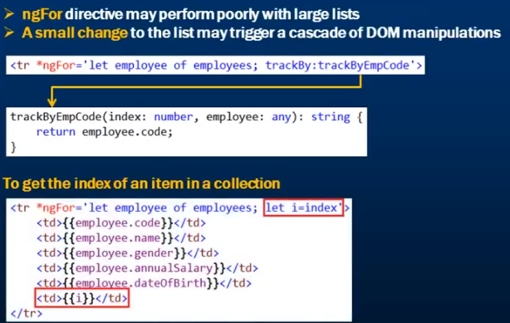

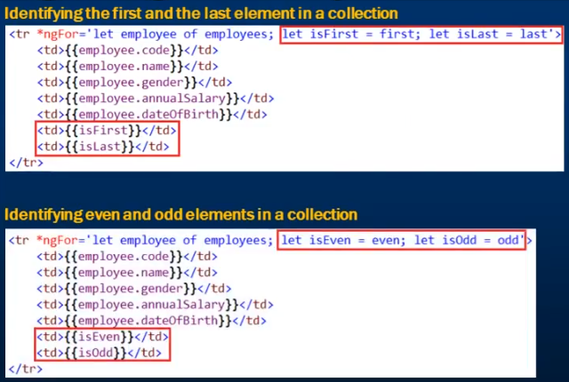

Dependency Injection:

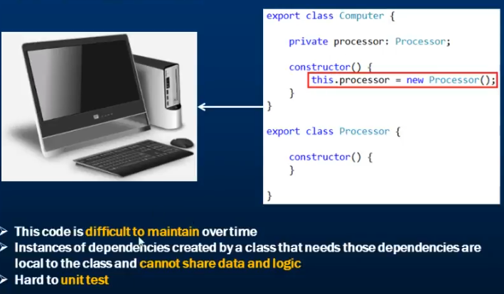

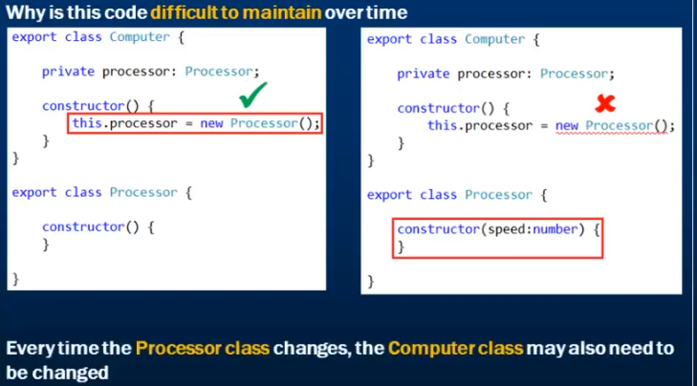

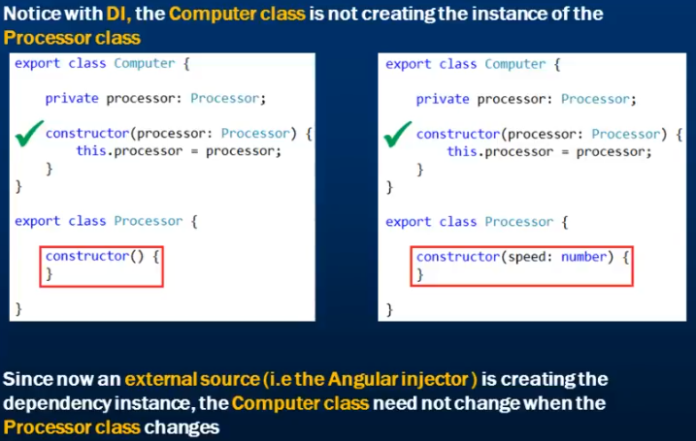

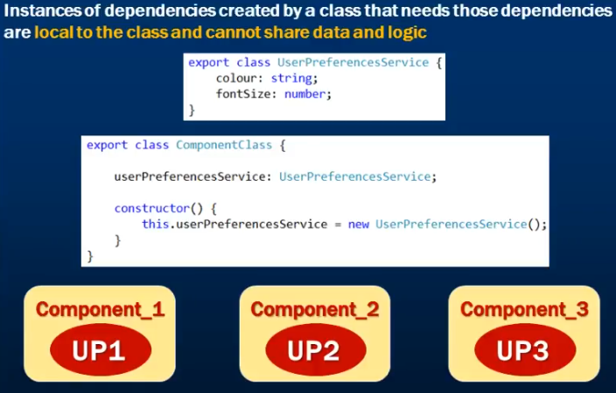

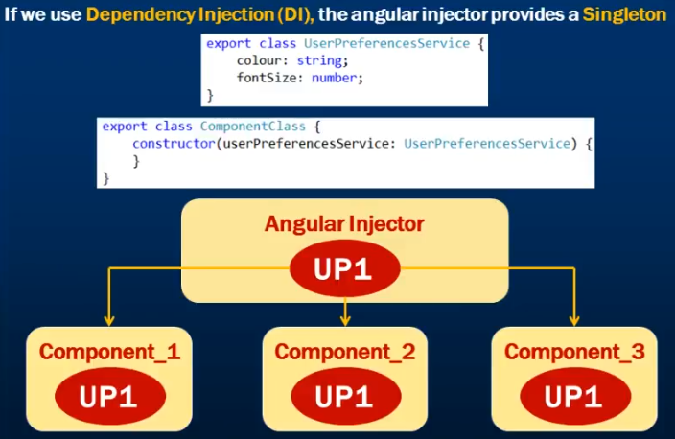

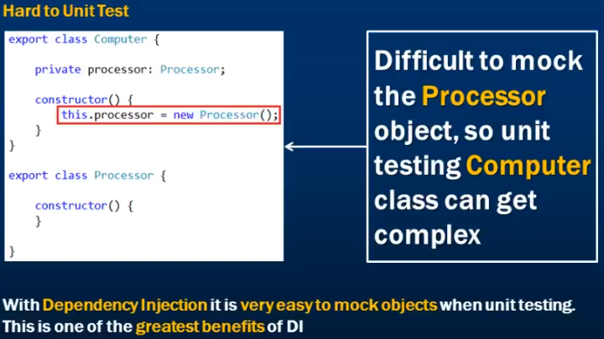

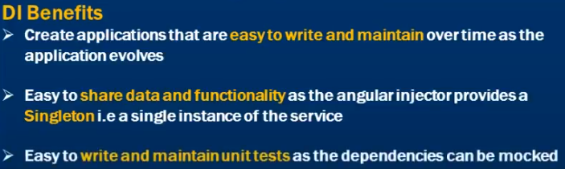

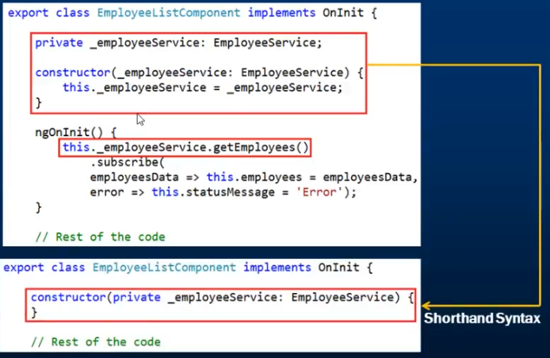

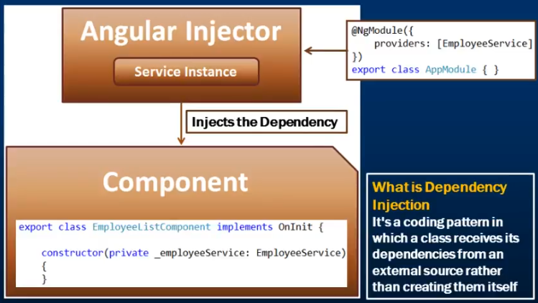

Singleton: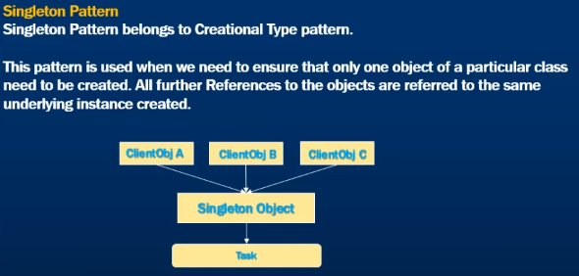

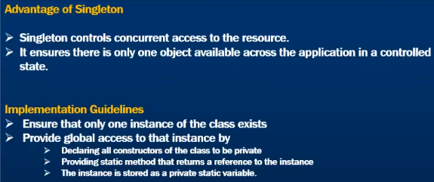

Angular Injector:

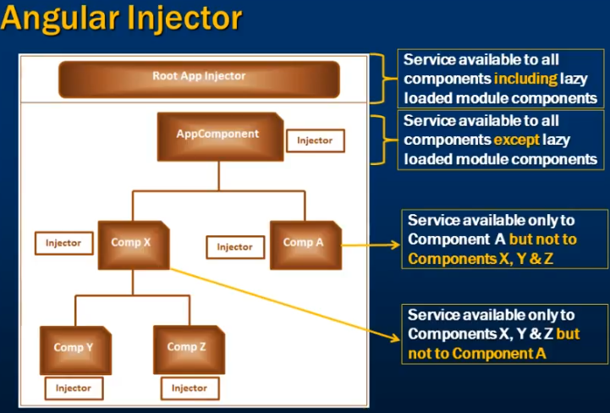

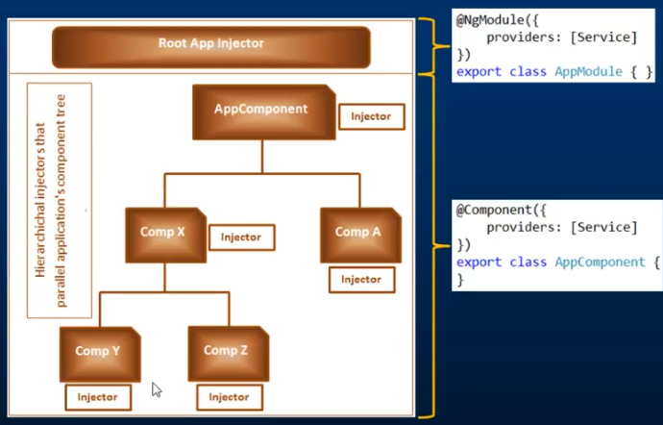

Component communication:

Client Server Architecture:

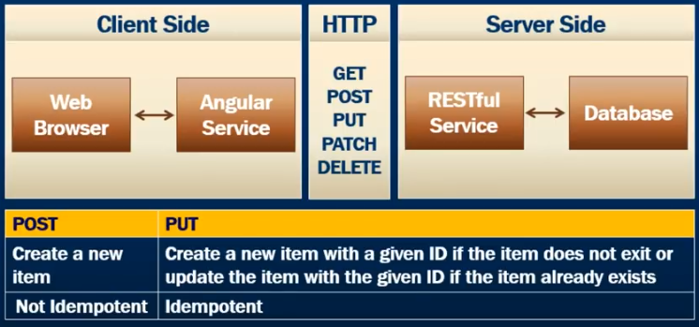

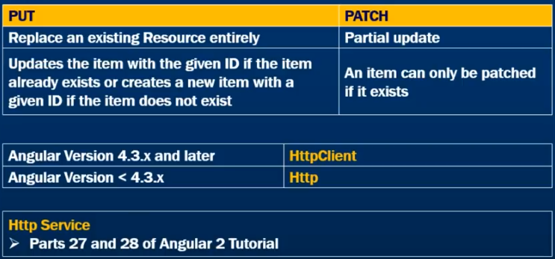

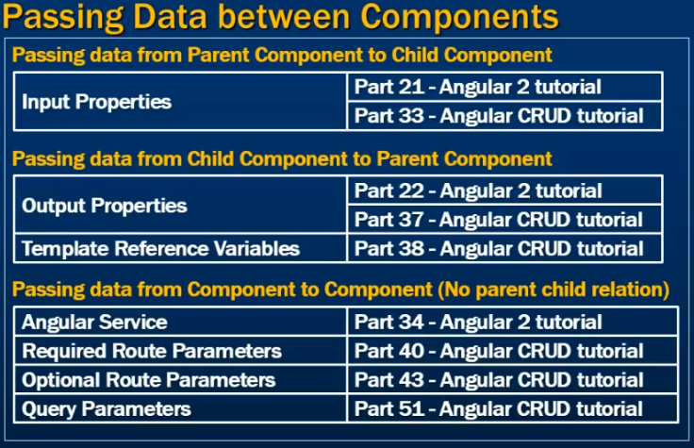

Input Properties:

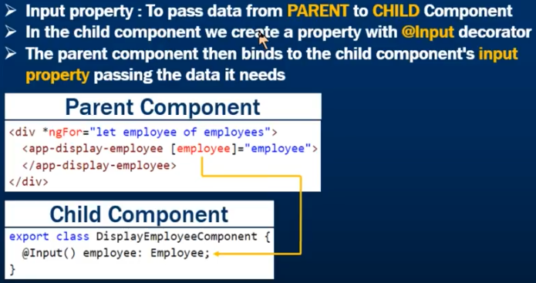

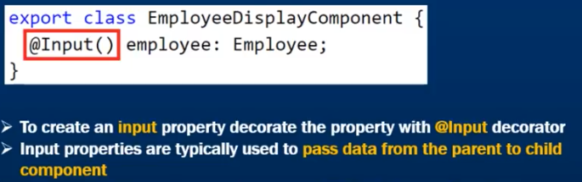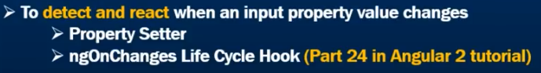

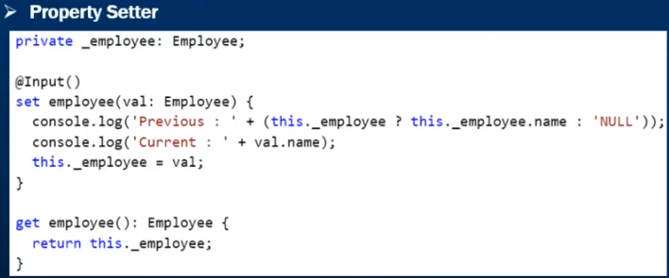

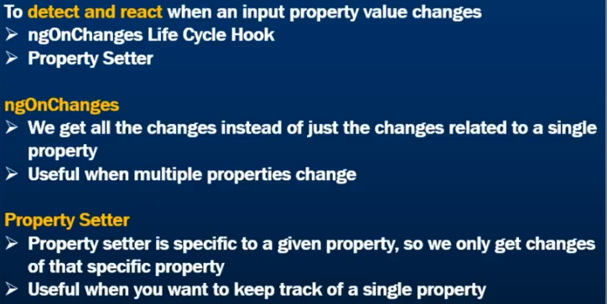

Output Property: 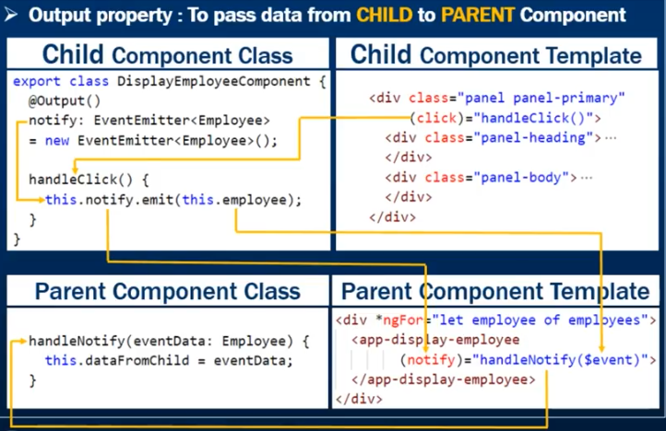

**Event Emitter:** A child component uses an event to pass data to a parent component

As the name implies EE object helps us emits a custom event to pass data from child to parent component.

Using EE event, we can pass only one value.

**Using template reference variable:**

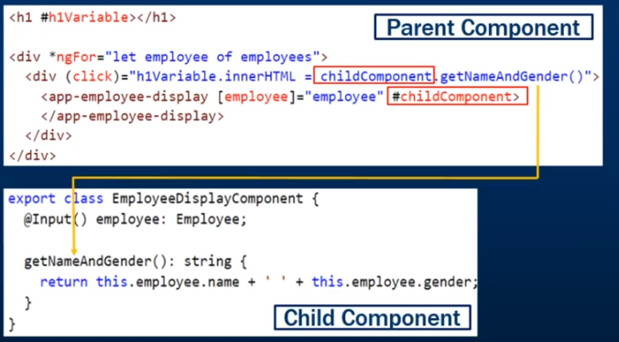

Component Lifecycle hooks:

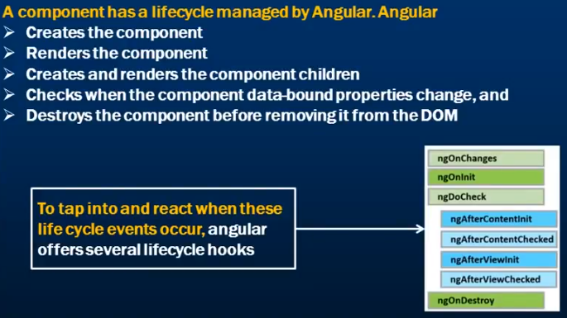

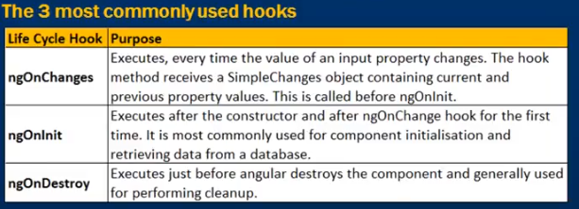

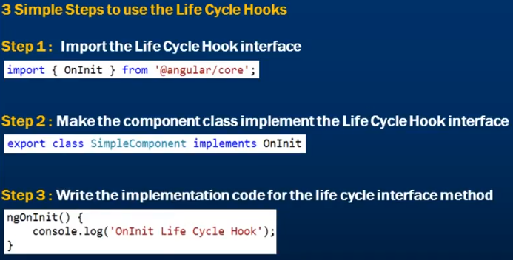

Services:

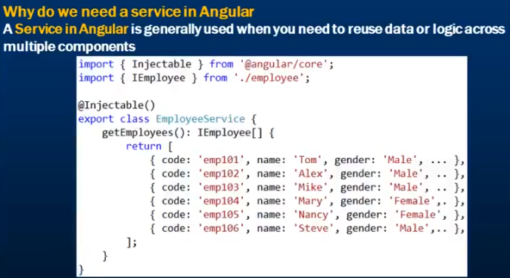

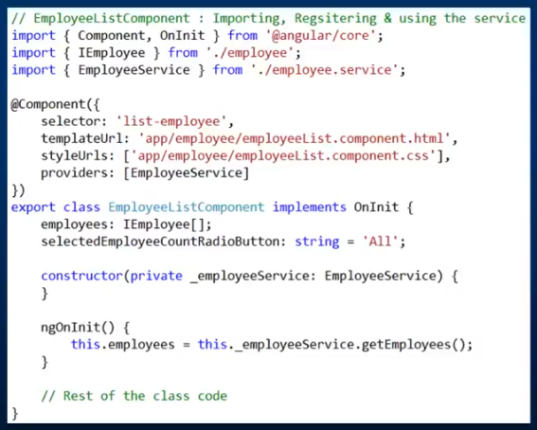

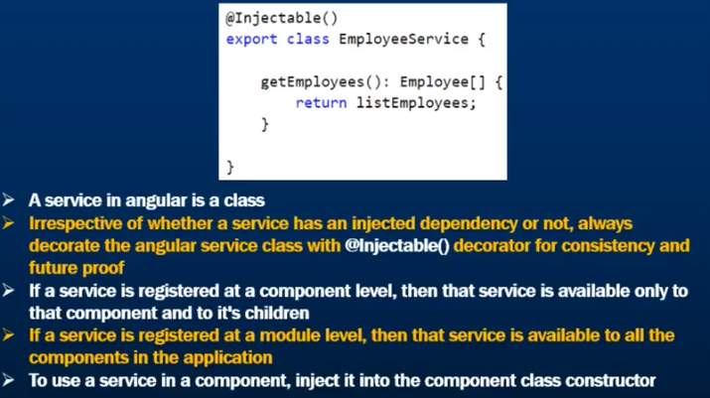

WebApi:

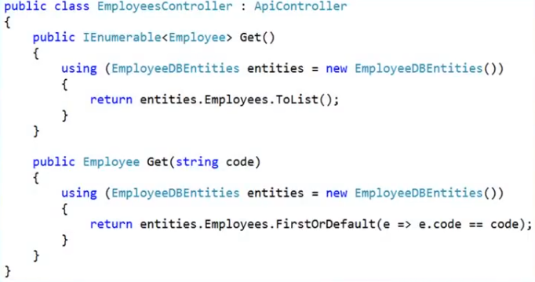

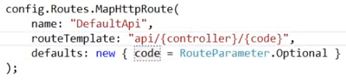

Consume in Angular:

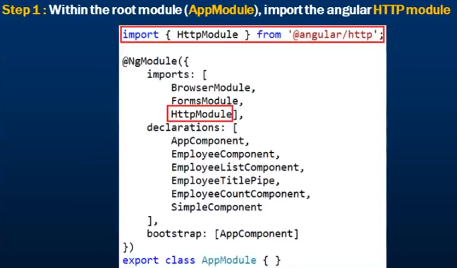

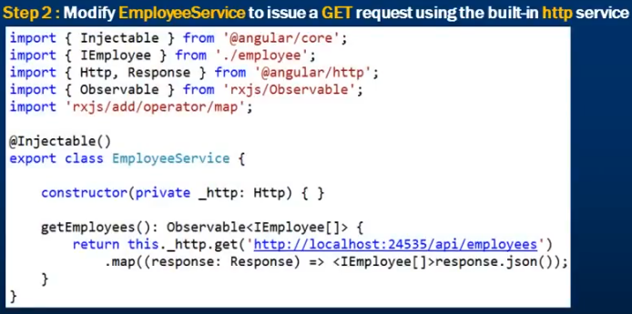

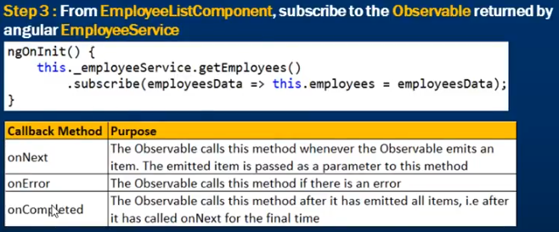

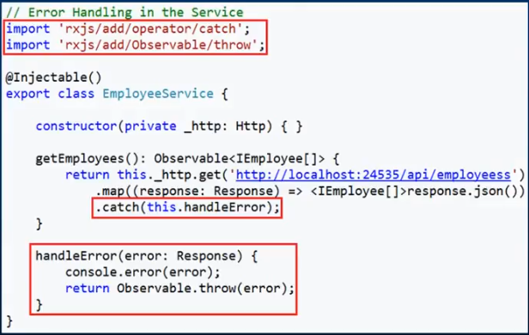

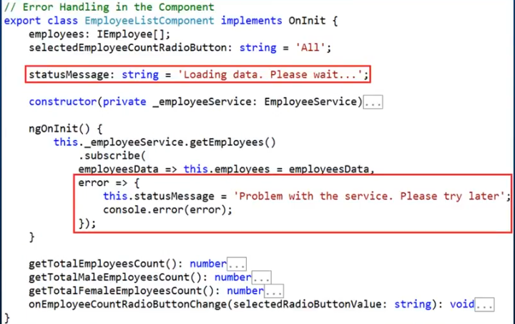

HttpClient Get: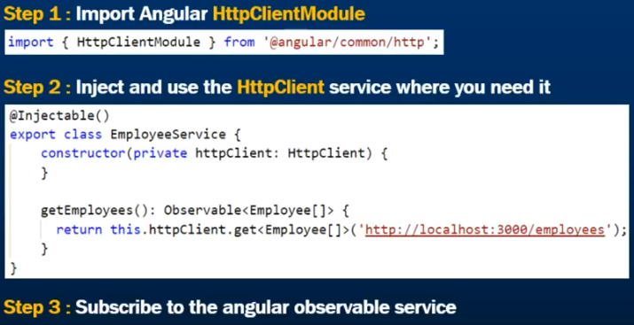

HttpClient POST:

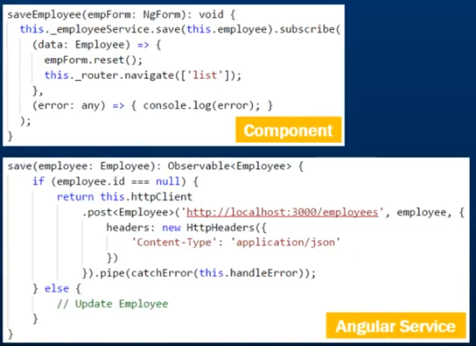

HttpClient PUT:

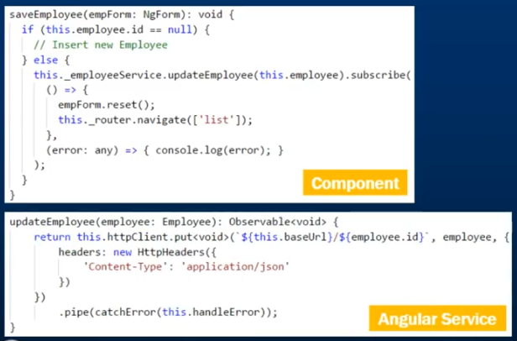

HttpClient Delete:

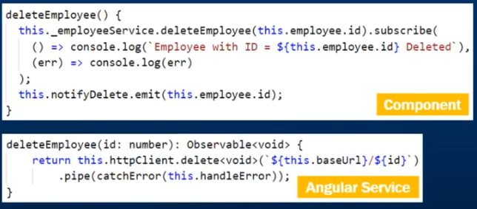

Observable:

An observable is an asynchronous pattern

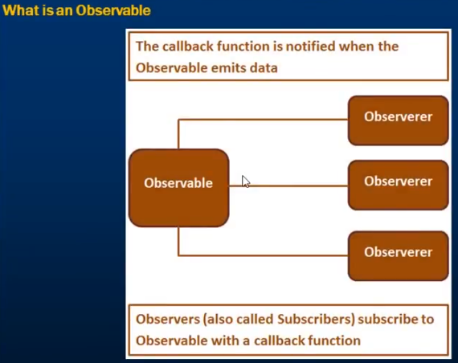

Create Observable from an array: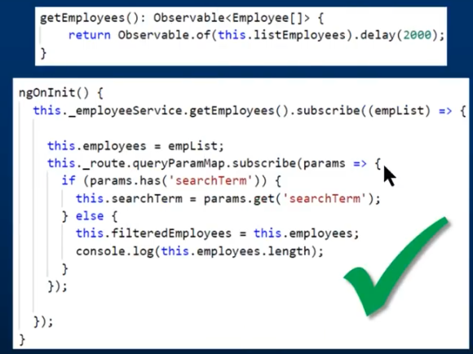

Promises: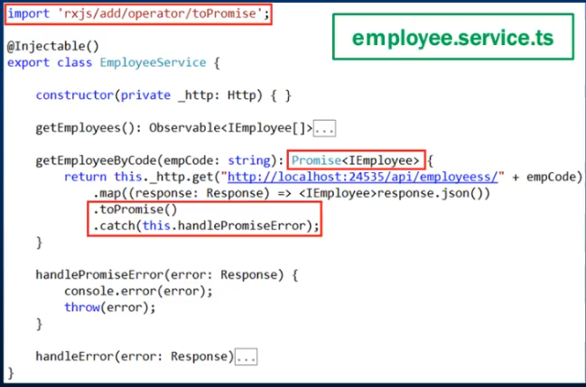

Promises VS Observable:

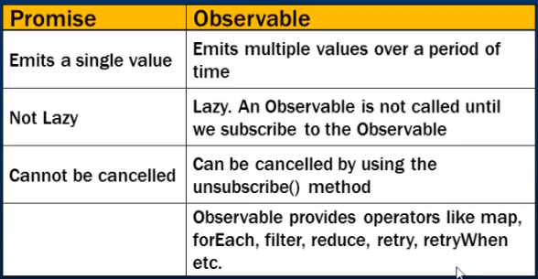At client side: Observable (Subscribe) VS Promises (then)

Routing:  
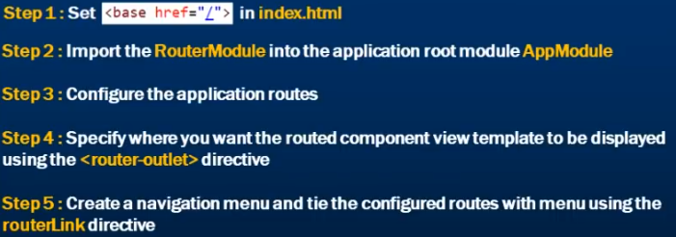  
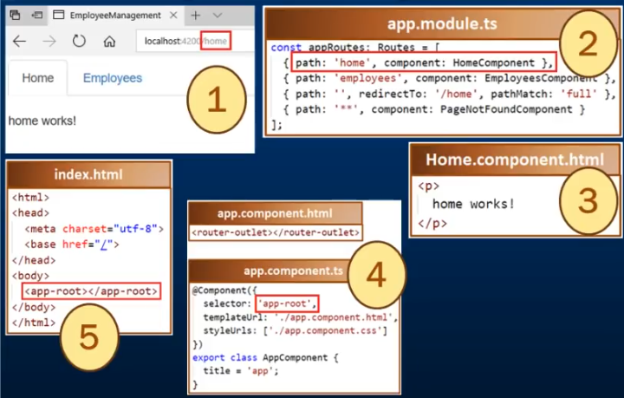

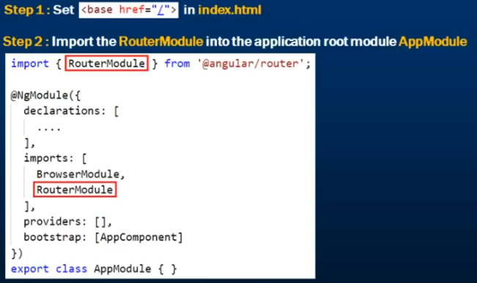

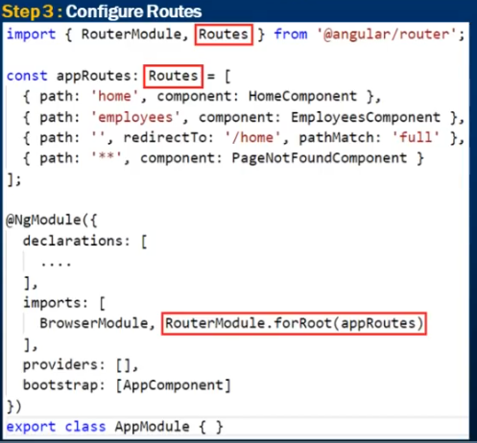

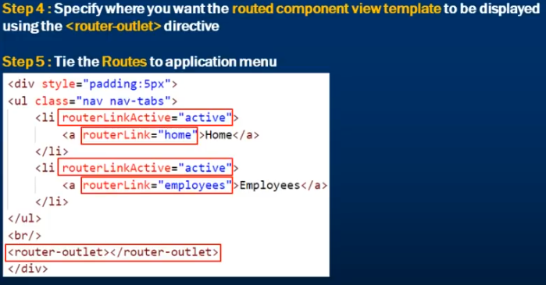

Route Parameters:

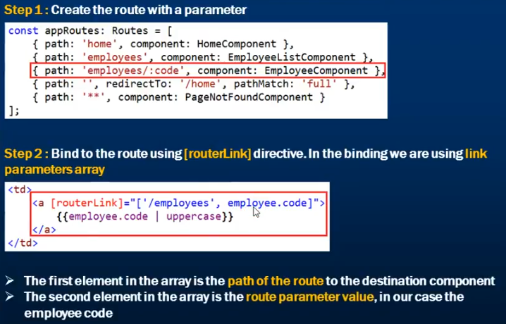

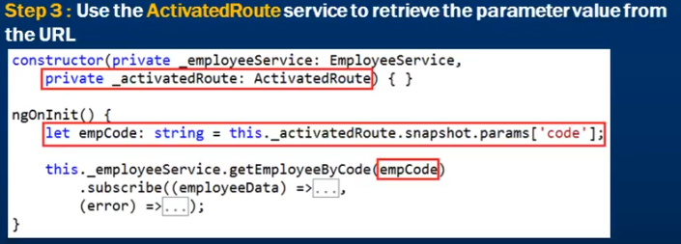

Route Parameters:

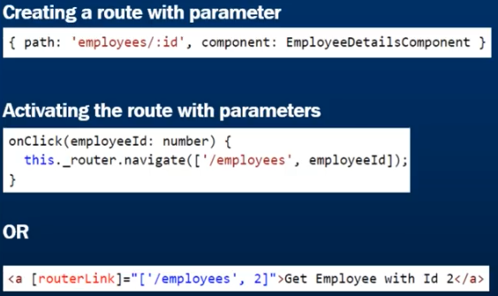

Read route Params: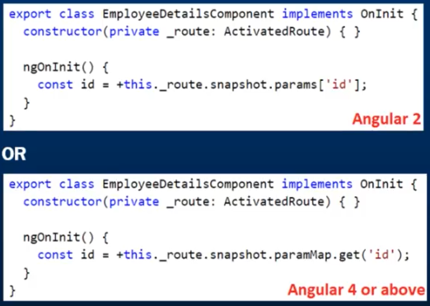

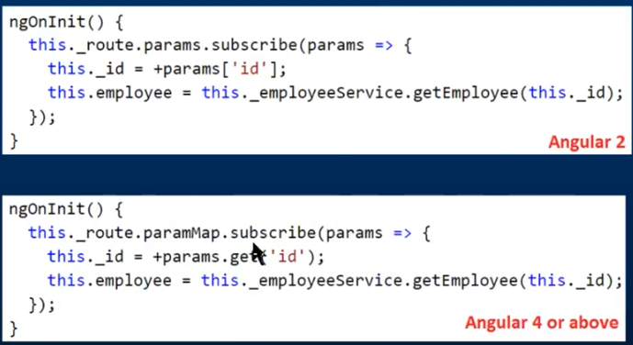

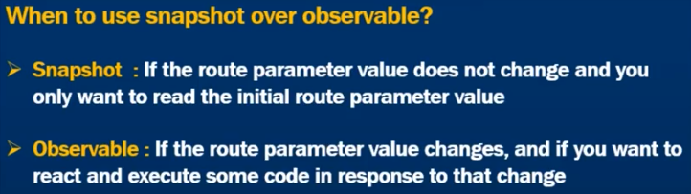

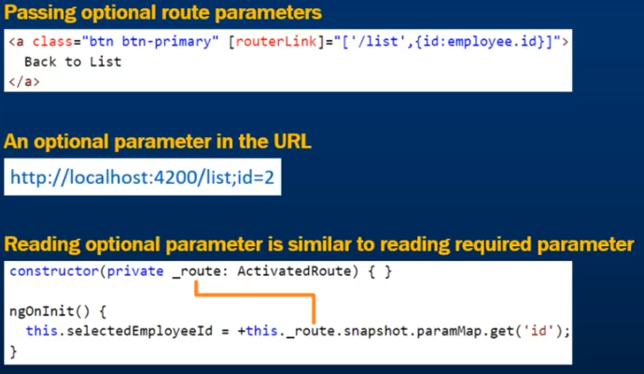

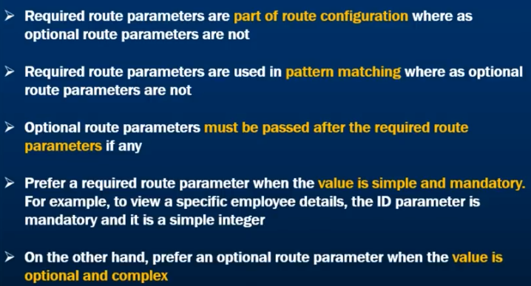

Query string Params: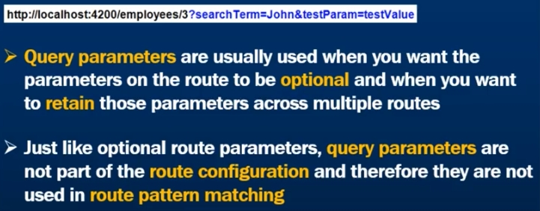

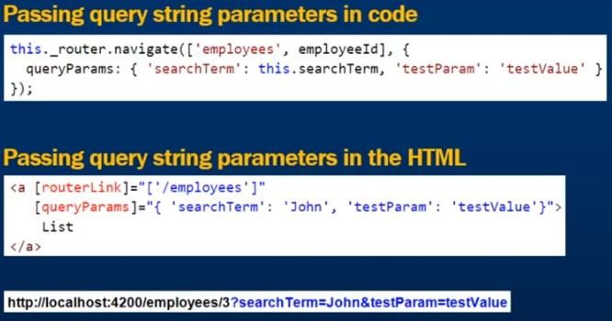

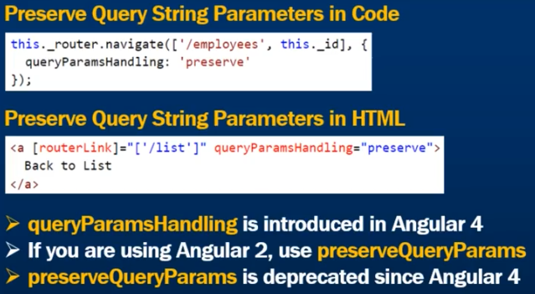

Read Query Params: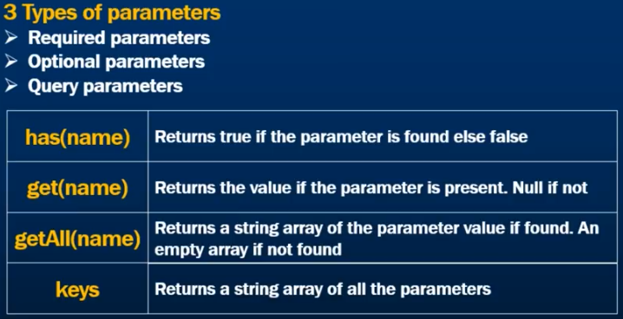

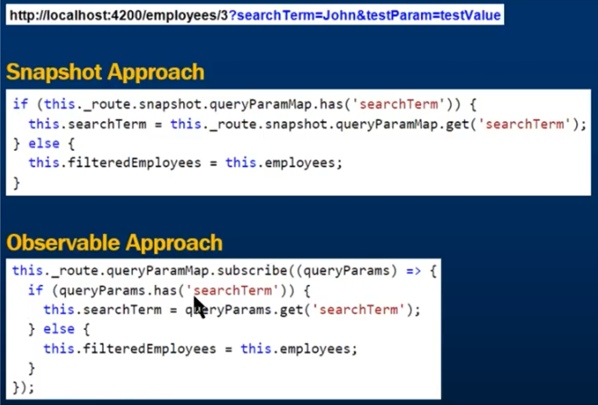

Route Navigation Events: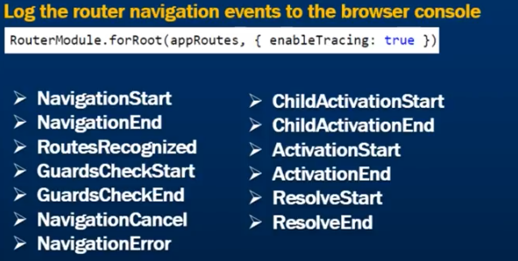

Route Loading indicator: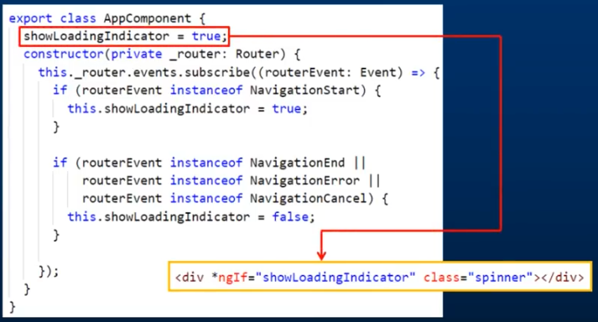

Router Navigate:

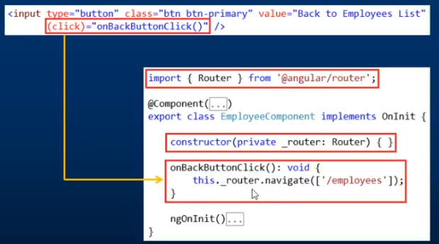

Route Guards: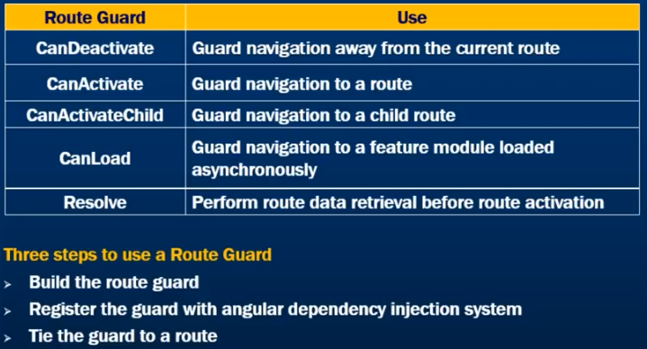

Build the route guard: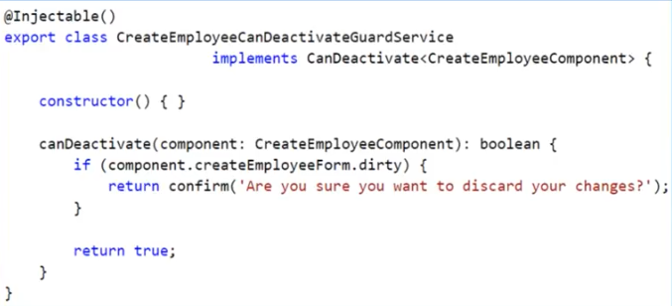

Register the guard:

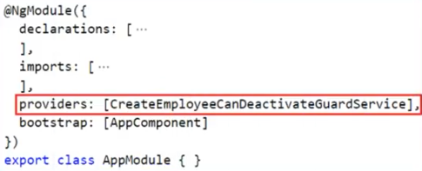

Tie the guard:

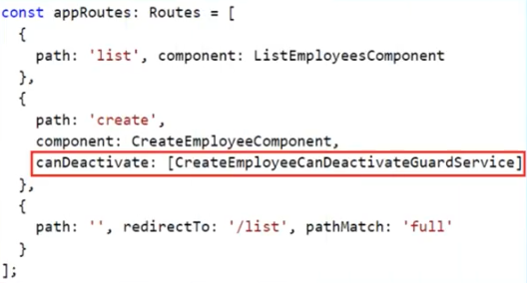

CanActivate Guard: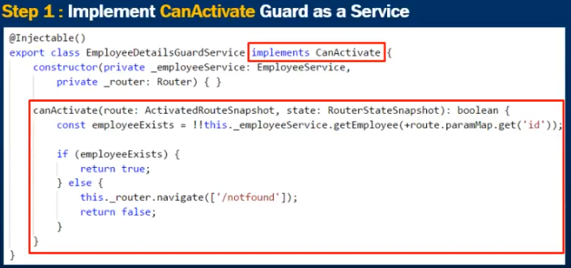

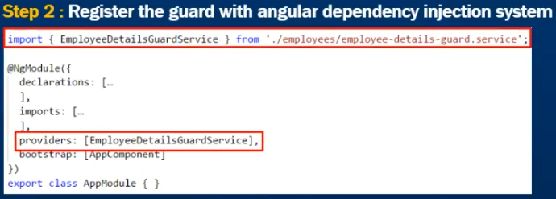

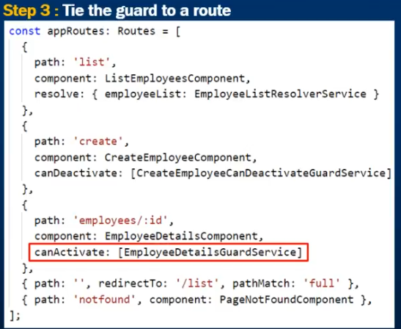

Route resolve guard: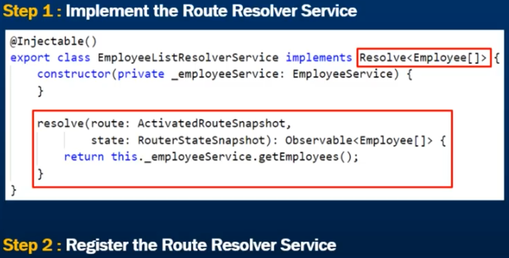

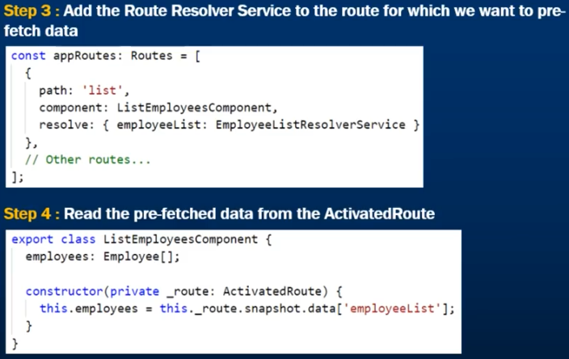

Forms:

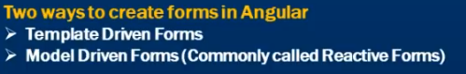

Template Driven Forms are generally used to create simple forms. Create complex forms using TDF is not recommended it is not easy to unit test template forms as most of the logic in the html

Reactive Forms are used to create more complex forms for example if you want to add form controls dynamically or perform cross field validation at run time we use reactive forms.

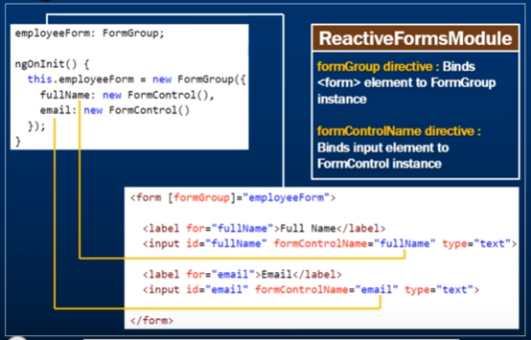

Radio button:

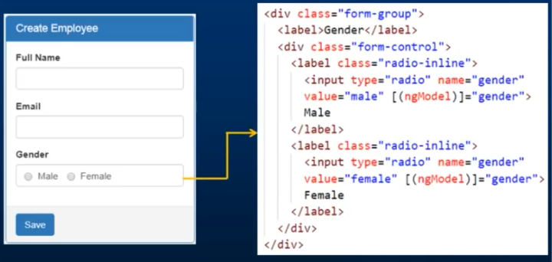

Dropdown: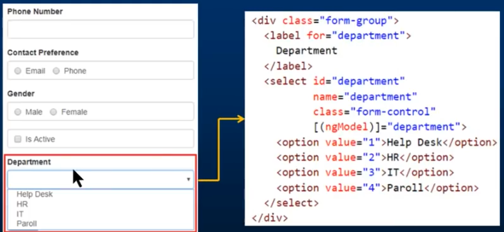

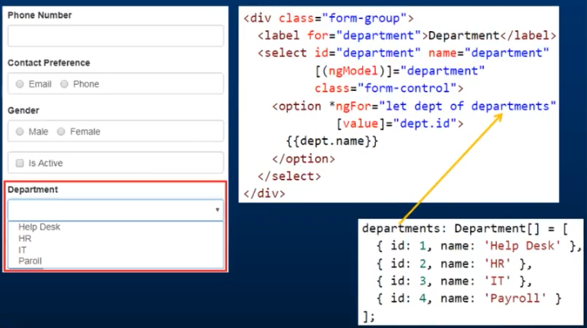

Datepicker:

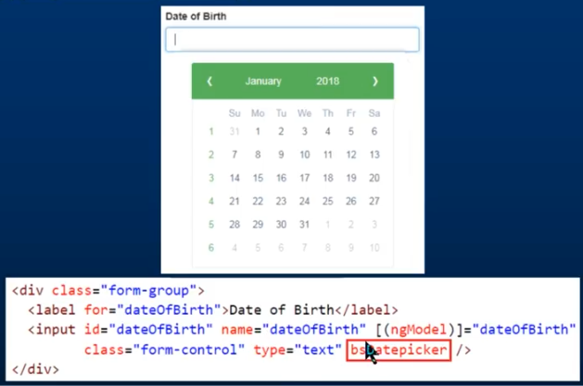

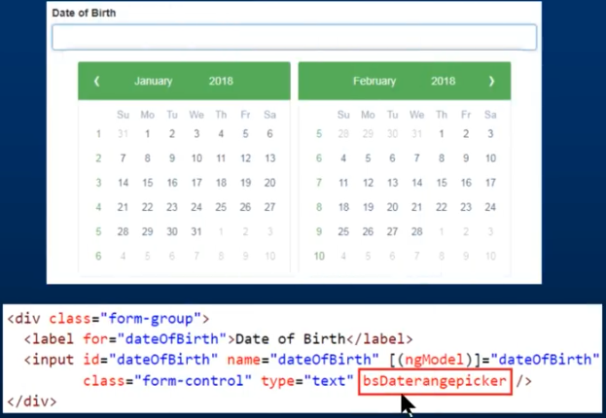

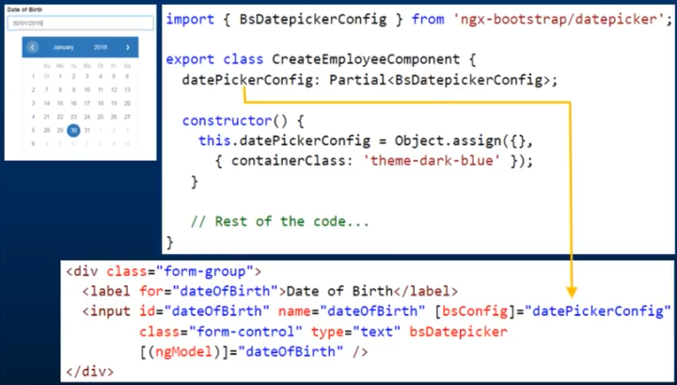

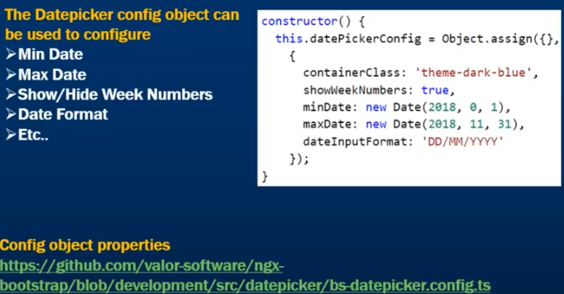

*ngif: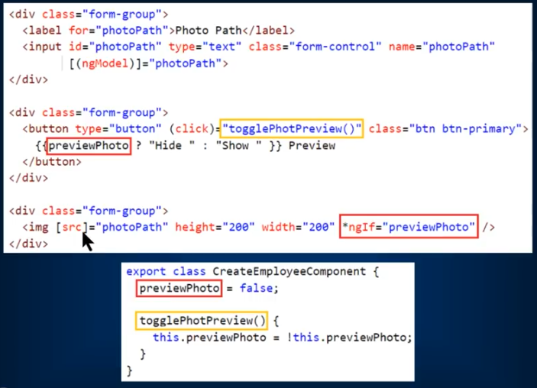

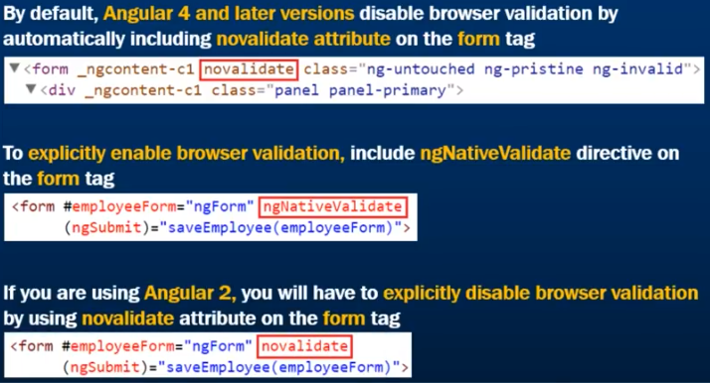

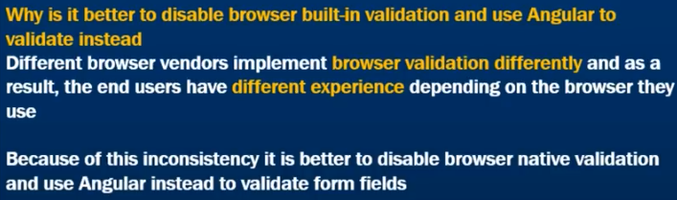

Form Validations:

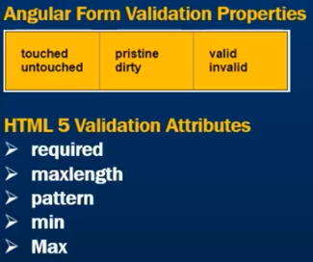

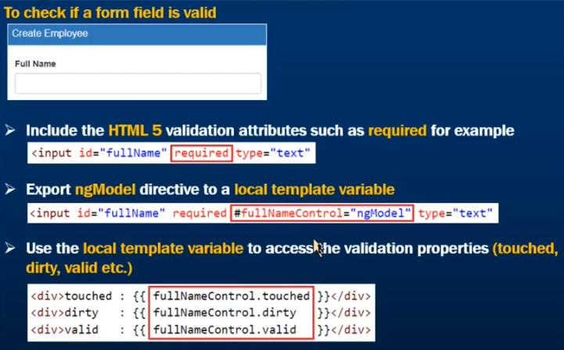

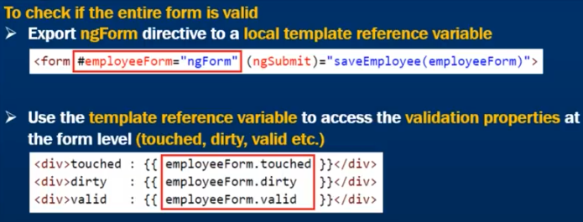

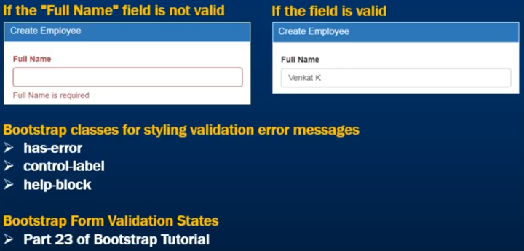

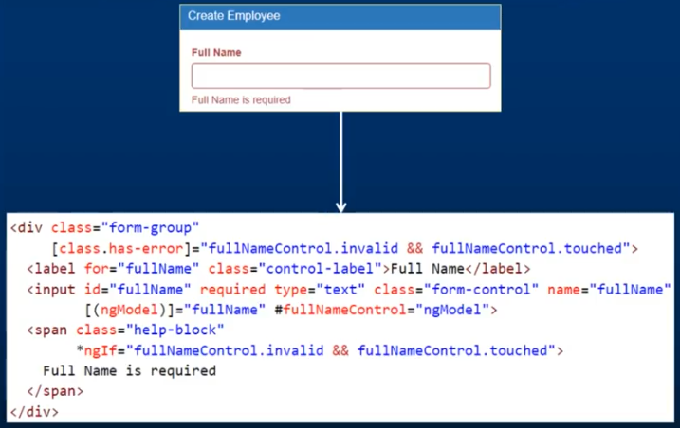

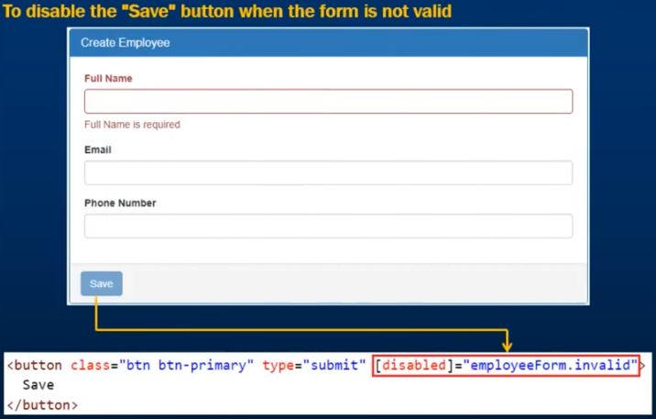

Email Validator: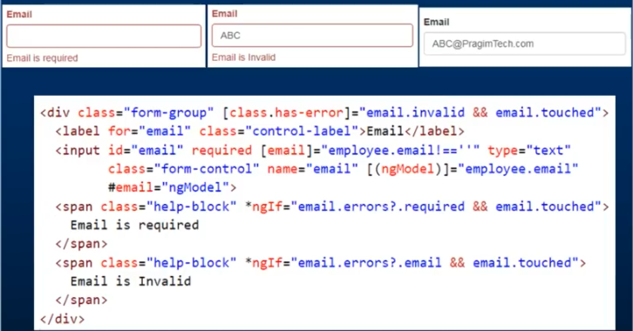

Pattern validator for email:

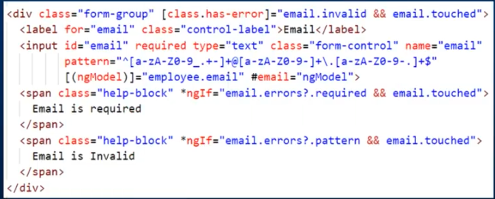

Radio button validator: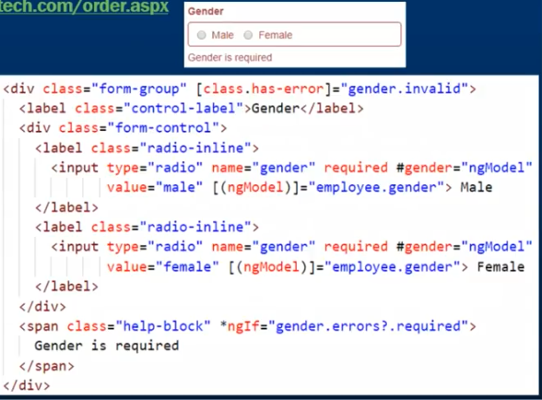

Add required field validator dynamically: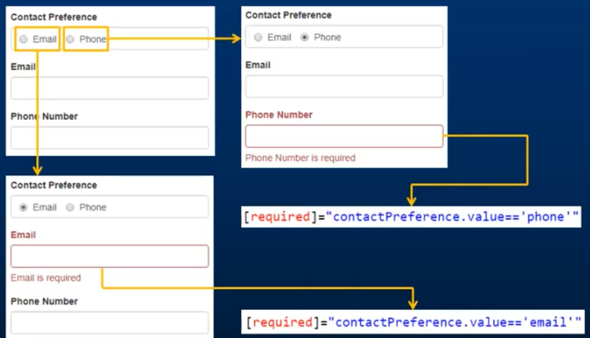

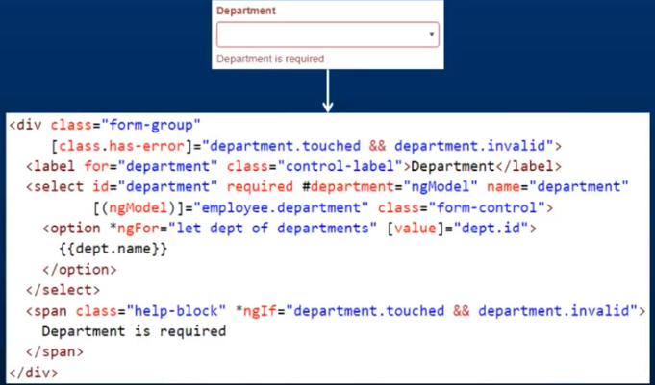

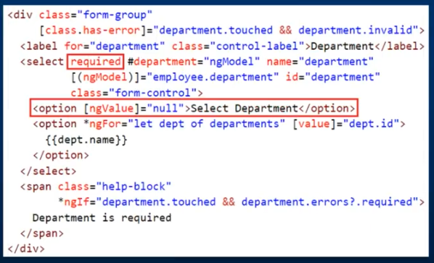

Custom Validator:

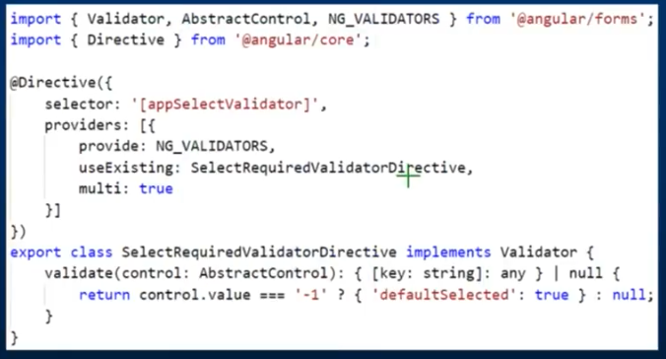

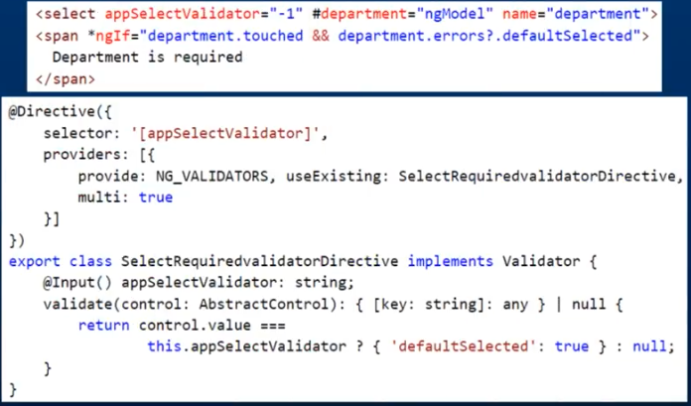

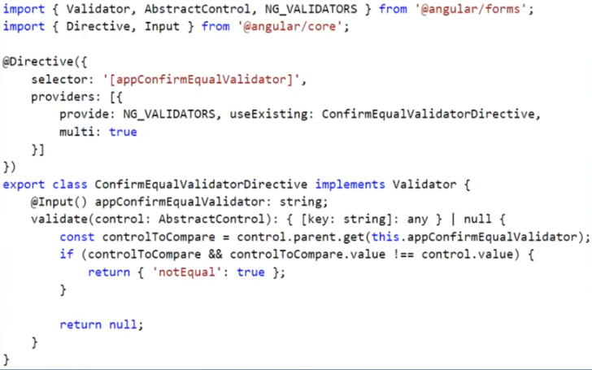

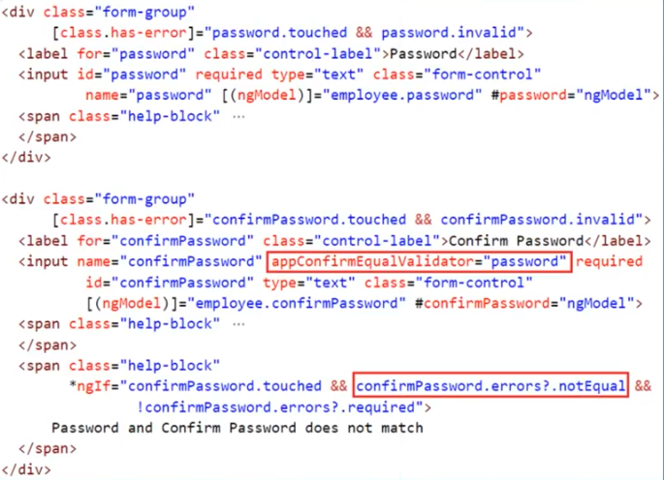

Switch Case:

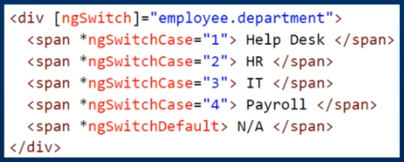

Form Reset:

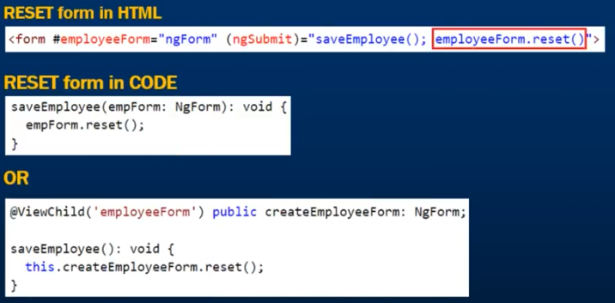

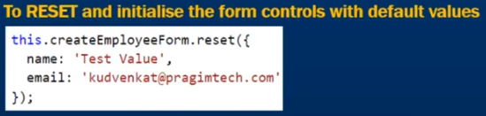

Javascript objects and reference variables:

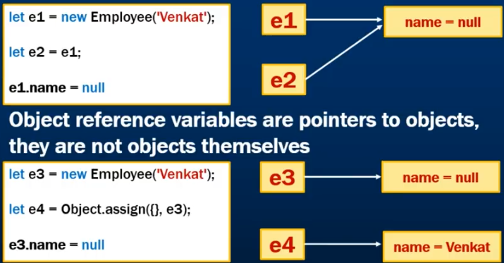

Custom pipe:

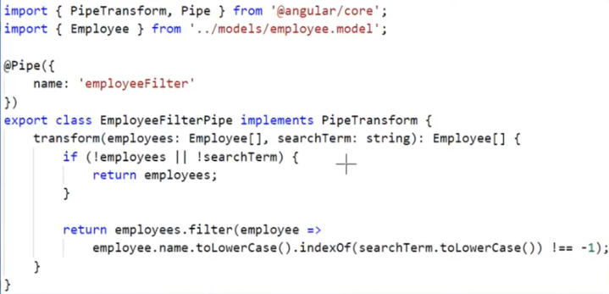

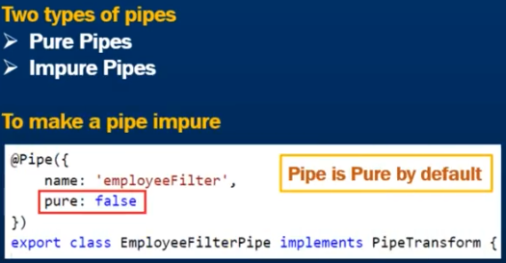

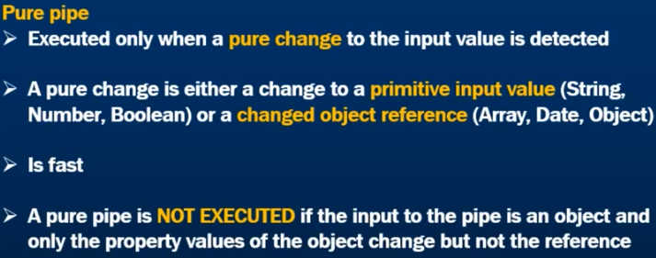

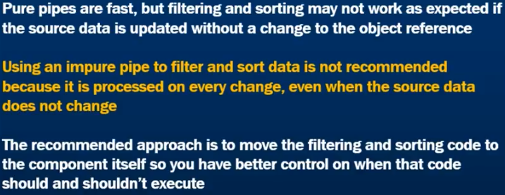

Data filtering in angular component:

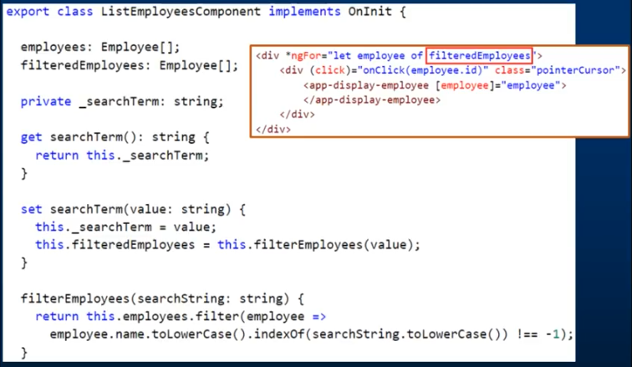

Accordion:

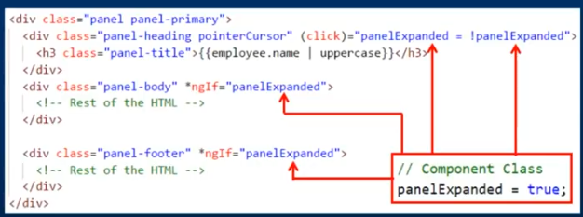

Reusable Accordion:

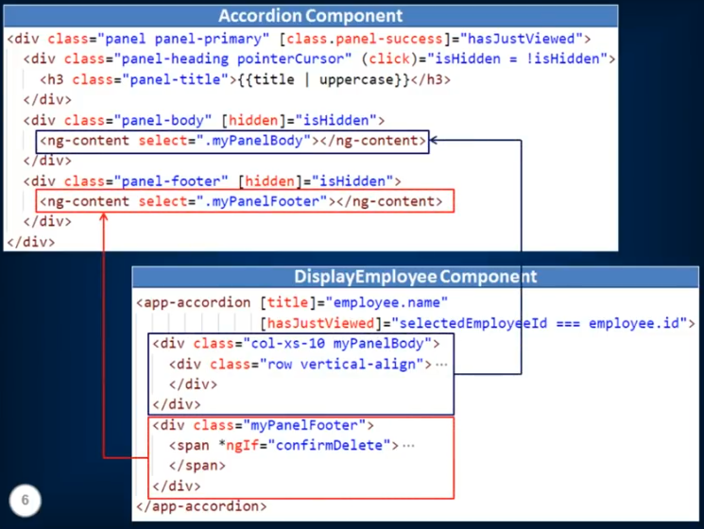

**Reactive Forms:**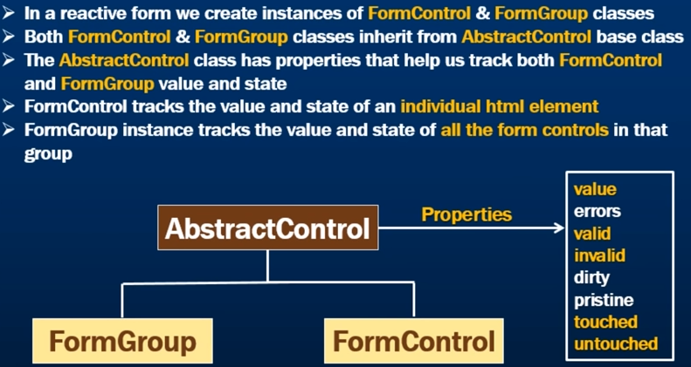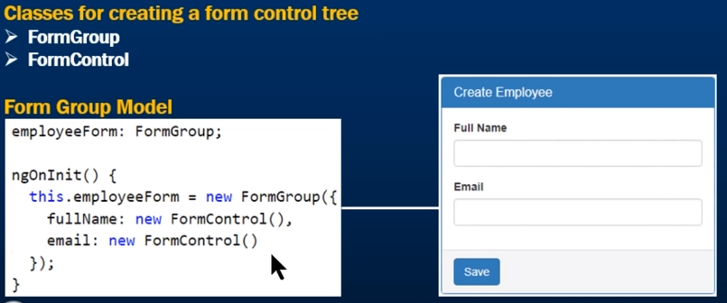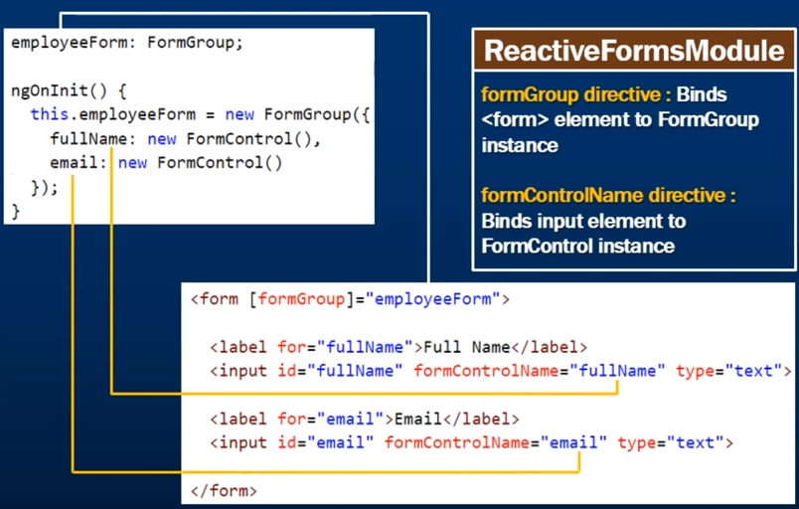

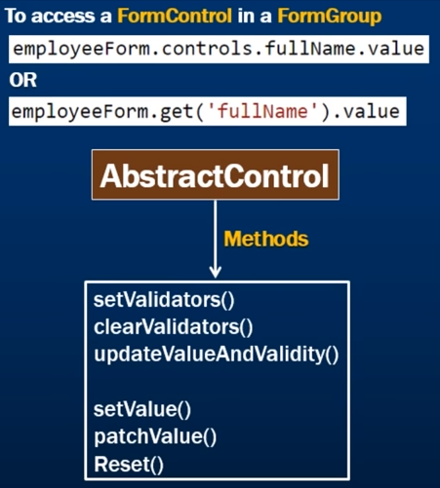

**Nested form groups: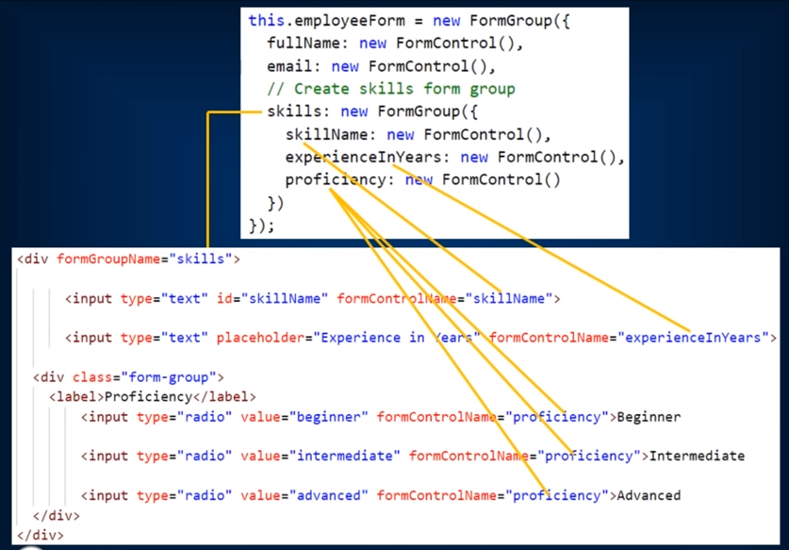**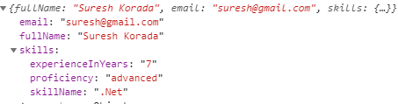

**SetValue() & PatchValue():**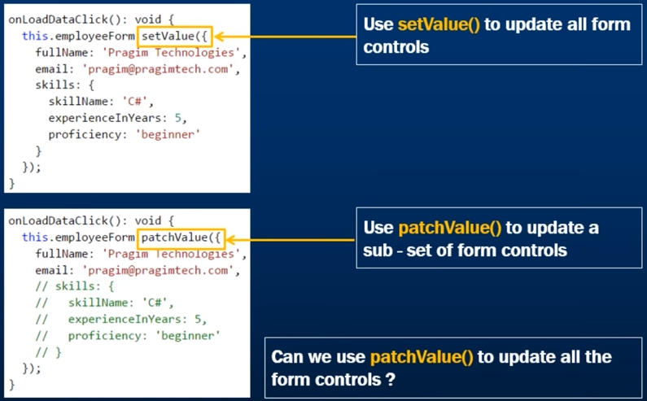Yes

**@HostListener:** When we need to react to some events occurring on the element, we can use Hostlistener

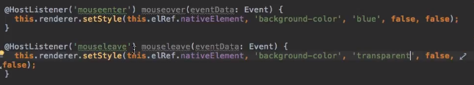

**CombineLatest & ForkJoin:**

**With combineLatest :**

const combined = Observable.combineLatest(

this.http.get('https://testdb1.firebaseio.com/.json').map((res: Response) => res.json()),

this.http.get('https://testdb2.firebaseio.com/.json').map((res: Response) => res.json())

)

combined.subscribe(latestValues => {

const [ data_changes , data_all ] = latestValues;

console.log( "data_changes" , data_changes);

console.log( "data_all" , data_all);

});

You can also handle it by forkJoin , but forkJoin will return data when all calls are finished and return result , but in combineLatest When any observable emits a value, emit the latest value from each.

**With forkJoin :**

const combined = Observable.forkJoin(

this.http.get('https://testdb1.firebaseio.com/.json').map((res: Response) => res.json()),

this.http.get('https://testdb2.firebaseio.com/.json').map((res: Response) => res.json())

)

combined.subscribe(latestValues => {

const [ data_changes , data_all ] = latestValues;

console.log( "data_changes" , data_changes);

console.log( "data_all" , data_all);

});

Call both and check the console log, you will get idea.

**Unit Testing**

**TDD vs BDD:**

|  |  |
| --- | --- |
| TDD | Bdd |
| Written by Developers | Written by Stakeholders or non-technical person |
| Written to each unit of code (Unit Tests) | Design high level scenarios to test expectation from software |
| Design level scenario | Design normally for acceptance testing |

The objective of unit testing is to test certain functionality with isolation.

**Protractor:**  
Protractor basically helps you to run test against your browser. You don’t need to add wait and sleep functions in your tests, it automatically figures out if one step finishes it would run the next step

**Jasmine (Framework):**  
Jasmine is behaviour driven test environment. It will allow you to structure you code properly

**Karma:**  
Karma will run those tests in multiple browsers.  
Basically you write your tests in Jasmine, it will run in protractor and it will allow you to do multiple browsers using Karma

Unit testing you focus on individual functions/components how they behave.

In e2e testing, overall application UI as a whole and how the user will interact with your application when they click on something what happened, where they go, make sure everything is fine on the page and it basically checks overall workflow of application

1. toBe
2. not.toBe
3. toEqual
4. toBeDefined
5. toBeUndefined
6. toMatch
7. toBeNull
8. toBeTruty
9. toBeFalsy
10. toContain
11. toBeLessThan
12. toBeGraterThan

|  |
| --- |
| describe('hellotest', ()=>{ |
|  |  |
|  | let expected = ''; |
|  | let notExpected = ''; |
|  | let expectMatch = null; |
|  |  |
|  | // runs before each test |
|  | beforeEach(()=> { |
|  | expected = 'hellotest'; |
|  | notExpected = 'hellotest123'; |
|  | expectMatch = new RegExp(/^hello/); |
|  | }); |
|  |  |
|  | // runs after each test |
|  | afterEach(()=>{ |
|  | expected = ''; |
|  | notExpected = ''; |
|  | }); |
|  |  |
|  | it('checks if hellotest is hellotest', |
|  | ()=> expect('hellotest').toBe(expected) |
|  | ); |
|  | it('checks if hellotest is not hellotest', |
|  | ()=> expect('hellotest').not.toBe(notExpected) |
|  | ); |
|  | it('checks if hellotest starts with hello', |
|  | ()=> expect('hellotest').toMatch(expectMatch) |
|  | ); |
|  | }); |

|  |
| --- |
| import { TestBed, inject } from '@angular/core/testing'; |
|  |  |
|  | import { TestService } from './test.service'; |
|  |  |
|  | describe('TestService', () => { |
|  | // setup service |
|  | beforeEach(() => { |
|  | TestBed.configureTestingModule({ |
|  | providers: [TestService] |
|  | }); |
|  | }); |
|  |  |
|  | it('should be created', inject([TestService], (service: TestService) => { |
|  | expect(service).toBeTruthy(); |
|  | })); |
|  |  |
|  | it('should have add function', |
|  | inject([TestService], (service: TestService) => { |
|  | expect(service.add).toBeTruthy(); |
|  | })); |
|  |  |
|  | it('should add correctly' , |
|  | inject([TestService], (service: TestService) => { |
|  | expect(service.add(1,2)).toEqual(3); |
|  | })); |
|  | }); |

We will continue to use ATB for the rest of this section because:

* It allows us to test the interaction of a directive or component with it’s template.
* It allows us to easily test change detection.
* It allows us to test and use Angulars DI framework,
* It allows us to test using the NgModule configuration we use in our application.
* It allows us to test user interaction via clicks & input field

/* tslint:disable:no-unused-variable */

import {TestBed, ComponentFixture} from '@angular/core/testing';

import {LoginComponent} from './login.component';

import {AuthService} from "./auth.service";

describe('Component: Login', () => {

let component: LoginComponent;

let fixture: ComponentFixture<LoginComponent>; (1)

let authService: AuthService;

beforeEach(() => {

TestBed.configureTestingModule({

declarations: [LoginComponent],

providers: [AuthService]

});

// create component and test fixture

fixture = TestBed.createComponent(LoginComponent); (2)

// get test component from the fixture

component = fixture.componentInstance; (3)

// UserService provided to the TestBed

authService = TestBed.get(AuthService); (4)

});

});

it('canLogin returns false when the user is not authenticated', () => {

spyOn(authService, 'isAuthenticated').and.returnValue(false);

expect(component.needsLogin()).toBeTruthy();

expect(authService.isAuthenticated).toHaveBeenCalled();

});

it('canLogin returns false when the user is not authenticated', () => {

spyOn(authService, 'isAuthenticated').and.returnValue(true);

expect(component.needsLogin()).toBeFalsy();

expect(authService.isAuthenticated).toHaveBeenCalled();

});

**Webpack:**

Webpack takes care of load modules and bundles all our code into single file so that the browser can load it in a single http request

Npm install --save-dev [webpack@1.13.1](mailto:webpack@1.13.1)

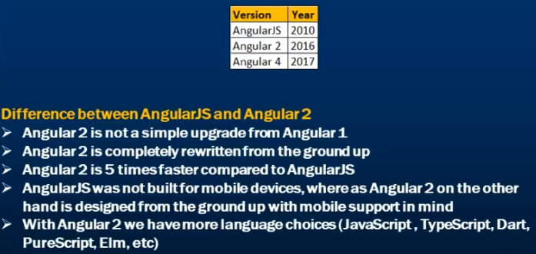

**Angular 4 Features:**

Typescript <1.8 is support for Angular 2, Typescript 2.1 & 2.2 Compatibility.

else along with *ngif

ng-template (wrap the logic in a block)  
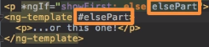

Renderer to Renderer2 (Renderer deprecated)

Email Validator directive

Animation features pulled out from @angular/core to own package @angular/animation

**Angular 5 Features:**

Angular 4 recompiles all the files on every change, making it too slow for development.  
Angular 5 introduces a watch option, only recompiling what’s needed and making it super fast

**Forms validation – updateOn:**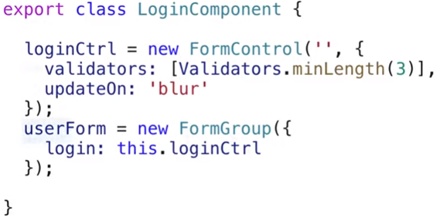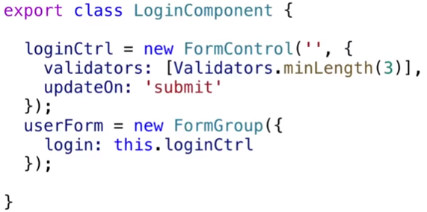

you can change default to blur or submit  
can be configured for all the fields at once or with ngModel or on form with ngModelOptions  
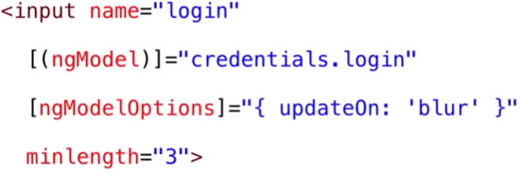

**i18n pipies:**The pipes depending on a locale have been rewritten (number, currency, percent, date) but you need to import the locale first  
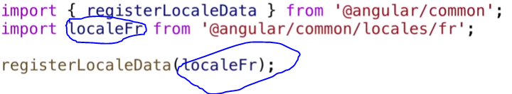  
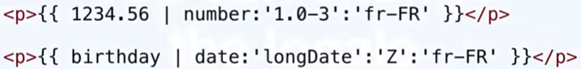

**Component vs Directives:**Directives associate behaviour to elements of DOM, consists of Structural, Attribute and Component types.

Components are type of directive in Angular that allows to utilize Web component functionality – encapsulated, reusable elements available throughout our application.

A component is not the only UI building block in Angular 2. There are also directives which allow you to attach behaviour to elements in the DOM.

A component is a directive with a view whereas a directive is a decorator with no view.

Component: To create a **reusable set of DOM elements of UI with custom behaviour**.   
Directive: To write **reusable behaviour to increase existing DOM elements.**

**HTTPIntercepter:**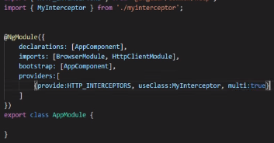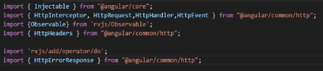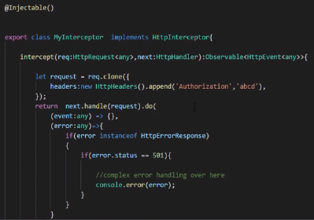

|  |  |  |
| --- | --- | --- |
| **Hook** | **Purpose** | **Timing** |
| ngOnChanges() | When the value of a data bound property changes, then this method is called. | Called before ngOnInit() and whenever one or more data-bound input properties change. |
| ngOnInit() | This is called whenever the initialization of the directive/component after Angular first displays the data-bound properties happens. | Called *once*, after the *first* ngOnChanges(). |
| ngDoCheck() | This is for the detection and to act on changes that Angular can't or won't detect on its own. | Called during every change detection run, immediately after ngOnChanges() and ngOnInit(). |
| [ngAfterContentInit()](https://angular.io/api/router/RouterLinkActive#ngAfterContentInit) | This is called in response after Angular projects external content into the component's view. | Called *once* after the first ngDoCheck(). |
| ngAfterContentChecked() | This is called in response after Angular checks the content projected into the component. | Called after the [ngAfterContentInit()](https://angular.io/api/router/RouterLinkActive" \l "ngAfterContentInit) and every subsequent ngDoCheck(). |
| [ngAfterViewInit()](https://angular.io/api/forms/NgForm#ngAfterViewInit) | This is called in response after Angular initializes the component's views and child views. | Called *once* after the first ngAfterContentChecked(). |
| ngAfterViewChecked() | This is called in response after Angular checks the component's views and child views. | Called after the [ngAfterViewInit()](https://angular.io/api/forms/NgForm" \l "ngAfterViewInit) and every subsequent ngAfterContentChecked(). |
| ngOnDestroy() | This is the cleanup phase just before Angular destroys the directive/component. | Called *just before* Angular destroys the directive/component. |

**Shadow DOM:**Shadow DOM brings **Encapsulation** to HTML Elements. Using the Shadow DOM, markup, styles, and behaviors are scoped to the element and do not clash with other nodes of the DOM. The Shadow DOM is part of Web Components, which encapsulates styles.

**View Encapsulation:**To emulate the Shadow DOM and encapsulate styles, Angular provides three types of View Encapsulation. They are as follows:

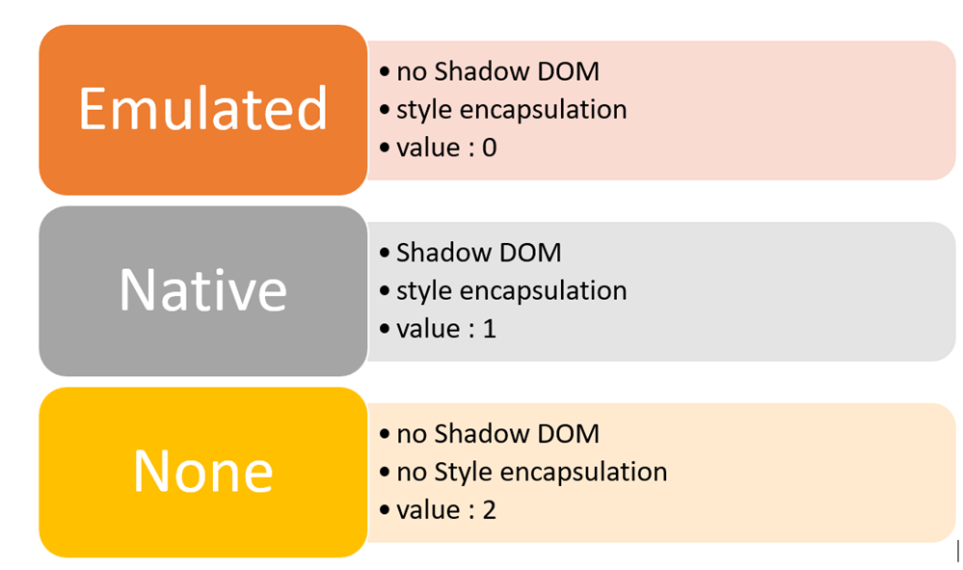

@Component({

selector: 'app-root',

templateUrl: './app.component.html',

styleUrls: ['./app.component.css'],

encapsulation: ViewEncapsulation.None

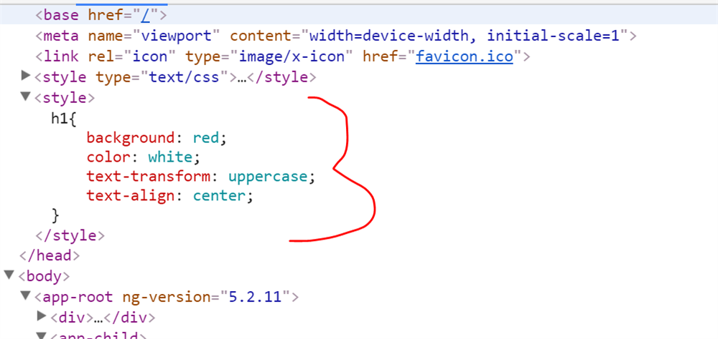

@Component({

----

encapsulation: ViewEncapsulation.Native

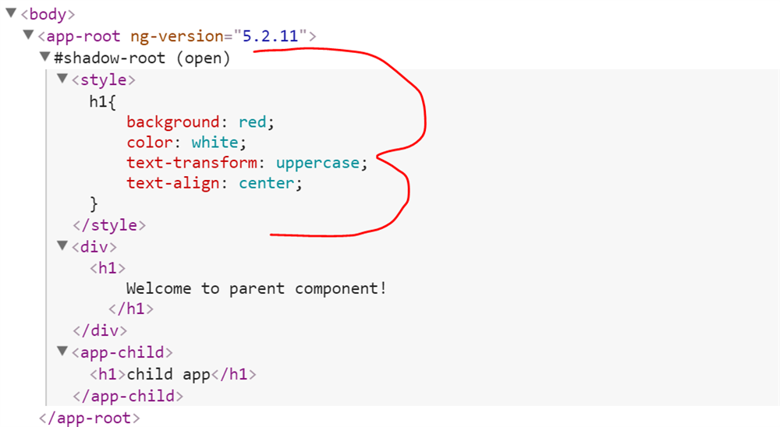

@Component({

encapsulation: ViewEncapsulation.Emulated

